EX. NO: 1-IMPLEMENTATION OF CAESAR CIPHER
AIM:
To implement the simple substitution technique named Caesar cipher using C language.

ALGORITHM:
STEP-1: Read the plain text from the user.
STEP-2: Read the key value from the user.
STEP-3: If the key is positive then encrypt the text by adding the key with each
character in the plain text.
STEP-4: Else subtract the key from the plain text.
STEP-5: Display the cipher text obtained above.
CODE:
#include <stdio.h>
#include <string.h>
#include <ctype.h>

int main()
{
char plain[100], cipher[100];
int key, i, length;

printf("Enter the plain text: ");
scanf("%99s", plain);

printf("Enter the key value: ");
scanf("%d", &key);

key = key % 26; // Keep key within alphabet range

printf("\nPLAIN TEXT: %s\n", plain);

/* Encryption */
printf("ENCRYPTED TEXT: ");
length = strlen(plain);

for (i = 0; i < length; i++)
{
cipher[i] = plain[i] + key;

if (isupper(plain[i]) && cipher[i] > 'Z')
cipher[i] -= 26;

if (islower(plain[i]) && cipher[i] > 'z')
cipher[i] -= 26;

printf("%c", cipher[i]);
}
cipher[length] = '\0';

/* Decryption */
printf("\nDECRYPTED TEXT: ");

for (i = 0; i < length; i++)
{
plain[i] = cipher[i] - key;

if (isupper(cipher[i]) && plain[i] < 'A')
plain[i] += 26;

if (islower(cipher[i]) && plain[i] < 'a')
plain[i] += 26;

printf("%c", plain[i]);
}
plain[length] = '\0';

return 0;
}
OUTPUT:
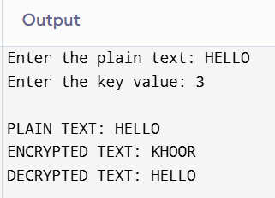

EX. NO: 2-IMPLEMENTATION OF PLAYFAIR CIPHER
AIM:
To write a C program to implement the Playfair Substitution technique.
ALGORITHM:
STEP-1: Read the plain text from the user.
STEP-2: Read the keyword from the user.
STEP-3: Arrange the keyword without duplicates in a 5*5 matrix in the row order and
fill the remaining cells with missed out letters in alphabetical order. Note that
„i‟ and „j‟ takes the same cell.
STEP-4: Group the plain text in pairs and match the corresponding corner letters by
forming a rectangular grid.
STEP-5: Display the obtained cipher text.
CODE: #include <stdio.h>
#include <string.h>
#include <ctype.h>

#define SIZE 5

char keyMatrix[SIZE][SIZE];

/* Find the position of a character in the key matrix */
void findPosition(char ch, int *row, int *col)
{
int i, j;

if (ch == 'J')
ch = 'I';

for (i = 0; i < SIZE; i++)
{
for (j = 0; j < SIZE; j++)
{
if (keyMatrix[i][j] == ch)
{
*row = i;
*col = j;
return;
}
}
}
}

/* Encrypt one pair of characters */
void playfair(char a, char b)
{
int r1, c1, r2, c2;

findPosition(a, &r1, &c1);
findPosition(b, &r2, &c2);

if (r1 == r2)
{
printf("%c%c",
keyMatrix[r1][(c1 + 1) % 5],
keyMatrix[r2][(c2 + 1) % 5]);
}
else if (c1 == c2)
{
printf("%c%c",
keyMatrix[(r1 + 1) % 5][c1],
keyMatrix[(r2 + 1) % 5][c2]);
}
else
{
printf("%c%c",
keyMatrix[r1][c2],
keyMatrix[r2][c1]);
}
}

int main()
{
char key[30], text[100];
char alphabet[] = "ABCDEFGHIKLMNOPQRSTUVWXYZ";
int used[26] = {0};
int i, j, k = 0;

printf("Enter the key: ");
scanf("%s", key);

printf("Enter the plain text: ");
scanf("%s", text);

/* Convert key to uppercase */
for (i = 0; key[i] != '\0'; i++)
{
key[i] = toupper(key[i]);
if (key[i] == 'J')
key[i] = 'I';

if (!used[key[i] - 'A'])
{
keyMatrix[k / 5][k % 5] = key[i];
used[key[i] - 'A'] = 1;
k++;
}
}

used['J' - 'A'] = 1;

/* Fill remaining letters */
for (i = 0; alphabet[i] != '\0'; i++)
{
if (!used[alphabet[i] - 'A'])
{
keyMatrix[k / 5][k % 5] = alphabet[i];
used[alphabet[i] - 'A'] = 1;
k++;
}
}

printf("\nKey Matrix:\n");
for (i = 0; i < 5; i++)
{
for (j = 0; j < 5; j++)
printf("%c ", keyMatrix[i][j]);
printf("\n");
}

/* Convert plaintext to uppercase */
for (i = 0; text[i] != '\0'; i++)
{
text[i] = toupper(text[i]);
if (text[i] == 'J')
text[i] = 'I';
}

printf("\nCipher Text: ");

for (i = 0; text[i] != '\0'; i++)
{
char ch1 = text[i];
char ch2;

if (text[i + 1] == '\0')
{
ch2 = 'X';
}
else if (text[i] == text[i + 1])
{
ch2 = 'X';
}
else
{
ch2 = text[++i];
}

playfair(ch1, ch2);
}

printf("\n");

return 0;
}
OUTPUT:
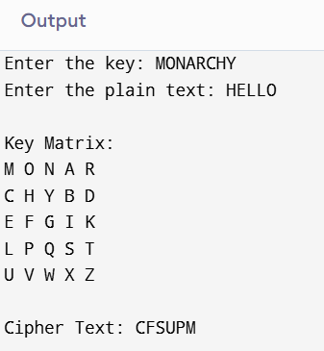
EX. NO: 3-IMPLEMENTATION OF HILL CIPHER
AIM:
To write a C program to implement the hill cipher substitution techniques.
ALGORITHM:
STEP-1: Read the plain text and key from the user.
STEP-2: Split the plain text into groups of length three.
STEP-3: Arrange the keyword in a 3*3 matrix.
STEP-4: Multiply the two matrices to obtain the cipher text of length three.
STEP-5: Combine all these groups to get the complete cipher text.
CODE:
#include <stdio.h>
#include <string.h>

int main()
{
unsigned int a[3][3] = {
{6, 24, 1},
{13, 16, 10},
{20, 17, 15}
};

unsigned int b[3][3] = {
{8, 5, 10},
{21, 8, 21},
{21, 12, 8}
};

int i, j, t;
unsigned int c[20], d[20];
char msg[20];

printf("Enter 3-letter plain text (CAPITAL letters): ");
scanf("%19s", msg);

/* Convert plaintext to numbers (A = 0, B = 1, ..., Z = 25) */
for (i = 0; i < 3; i++)
{
c[i] = msg[i] - 'A';
}

/* Encryption */
for (i = 0; i < 3; i++)
{
t = 0;
for (j = 0; j < 3; j++)
{
t += a[i][j] * c[j];
}
d[i] = t % 26;
}

printf("\nEncrypted Cipher Text: ");
for (i = 0; i < 3; i++)
{
printf("%c", d[i] + 'A');
}

/* Decryption */
for (i = 0; i < 3; i++)
{
t = 0;
for (j = 0; j < 3; j++)
{
t += b[i][j] * d[j];
}
c[i] = t % 26;
}

printf("\nDecrypted Plain Text: ");
for (i = 0; i < 3; i++)
{
printf("%c", c[i] + 'A');
}

printf("\n");

return 0;
}
OUTPUT:
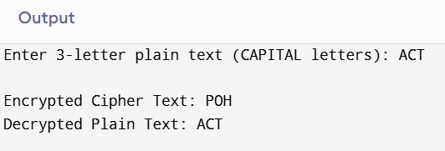

EX. NO: 4-IMPLEMENTATION OF VIGENERE CIPHER
AIM:
To implement the Vigenere Cipher substitution technique using C program.
ALGORITHM:
STEP-1: Arrange the alphabets in row and column of a 26*26 matrix.
STEP-2: Circulate the alphabets in each row to position left such that the first letter is
attached to last.
STEP-3: Repeat this process for all 26 rows and construct the final key matrix.
STEP-4: The keyword and the plain text is read from the user.
STEP-5: The characters in the keyword are repeated sequentially so as to match with
that of the plain text.
STEP-6: Pick the first letter of the plain text and that of the keyword as the row indices
and column indices respectively.
STEP-7: The junction character where these two meet forms the cipher character.
STEP-8: Repeat the above steps to generate the entire cipher text.
CODE:
#include <stdio.h>
#include <string.h>
#include <ctype.h>
#include <stdlib.h>

void encipher(void);
void decipher(void);

int main()
{
int choice;

while (1)
{
printf("\n========== VIGENERE CIPHER ==========\n");
printf("1. Encrypt Text\n");
printf("2. Decrypt Text\n");
printf("3. Exit\n");

printf("\nEnter Your Choice : ");
scanf("%d", &choice);

switch (choice)
{
case 1:
encipher();
break;

case 2:
decipher();
break;

case 3:
return 0;

default:
printf("\nInvalid Choice!\n");
}
}
}

void encipher(void)
{
int i, j = 0;
char input[100], key[100];

printf("\nEnter Plain Text : ");
scanf("%s", input);

printf("Enter Key : ");
scanf("%s", key);

printf("\nCipher Text : ");

for (i = 0; input[i] != '\0'; i++)
{
if (j == strlen(key))
j = 0;

printf("%c", (((toupper(input[i]) - 'A') +
(toupper(key[j]) - 'A')) % 26) + 'A');

j++;
}

printf("\n");
}

void decipher(void)
{
int i, j = 0;
char input[100], key[100];

printf("\nEnter Cipher Text : ");
scanf("%s", input);

printf("Enter Key : ");
scanf("%s", key);

printf("\nPlain Text : ");

for (i = 0; input[i] != '\0'; i++)
{
if (j == strlen(key))
j = 0;

printf("%c", (((toupper(input[i]) - 'A') -
(toupper(key[j]) - 'A') + 26) % 26) + 'A');

j++;
}

printf("\n");
}
OUTPUT:
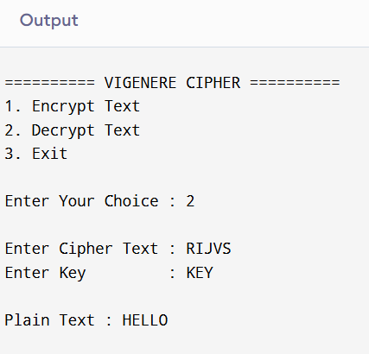

EX. NO: 5-IMPLEMENTATION OF RAIL FENCE – ROW & COLUMN TRANSFORMATION TECHNIQUE
AIM:
To write a C program to implement the rail fence transposition technique.
ALGORITHM:
STEP-1: Read the Plain text.
STEP-2: Arrange the plain text in row columnar matrix format.
STEP-3: Now read the keyword depending on the number of columns of the plain text.
STEP-4: Arrange the characters of the keyword in sorted order and the corresponding
columns of the plain text.
STEP-5: Read the characters row wise or column wise in the former order to get the
cipher text.
CODE:
#include <stdio.h>
#include <string.h>

int main()
{
int i, j, k, l;
char a[100], c[100], d[100];

printf("\n\t\tRAIL FENCE TECHNIQUE\n");

printf("\nEnter the input string : ");
scanf("%99s", a);

l = strlen(a);

/* Encryption */
j = 0;

for(i = 0; i < l; i++)
{
if(i % 2 == 0)
c[j++] = a[i];
}

for(i = 0; i < l; i++)
{
if(i % 2 == 1)
c[j++] = a[i];
}

c[j] = '\0';

printf("\nCipher Text : %s\n", c);

/* Decryption */
if(l % 2 == 0)
k = l / 2;
else
k = (l / 2) + 1;

j = 0;
for(i = 0; i < k; i++)
{
d[j] = c[i];
j += 2;
}

j = 1;
for(i = k; i < l; i++)
{
d[j] = c[i];
j += 2;
}

d[l] = '\0';

printf("Plain Text : %s\n", d);

return 0;
}
OUTPUT:
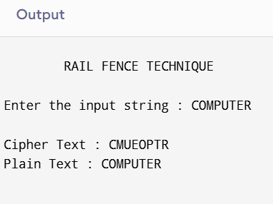

EX. NO: 6-IMPLEMENTATION OF DES
AIM:
To write a C program to implement Data Encryption Standard (DES) using C Language.
ALGORITHM:
STEP-1: Read the 64-bit plain text.
STEP-2: Split it into two 32-bit blocks and store it in two different arrays.
STEP-3: Perform XOR operation between these two arrays.
STEP-4: The output obtained is stored as the second 32-bit sequence and the original
second 32-bit sequence forms the first part.
STEP-5: Thus the encrypted 64-bit cipher text is obtained in this way. Repeat the same
process for the remaining plain text characters.
CODE:
import javax.crypto.Cipher;
import javax.crypto.KeyGenerator;
import javax.crypto.SecretKey;
import java.util.Base64;

public class DESDemo {

public static void main(String[] args) {
try {
String message = "HELLO";

KeyGenerator keyGenerator = KeyGenerator.getInstance("DES");
SecretKey secretKey = keyGenerator.generateKey();

Cipher cipher = Cipher.getInstance("DES");

cipher.init(Cipher.ENCRYPT_MODE, secretKey);
byte[] encrypted = cipher.doFinal(message.getBytes());

String encryptedText = Base64.getEncoder().encodeToString(encrypted);
System.out.println("Encrypted Text: " + encryptedText);

cipher.init(Cipher.DECRYPT_MODE, secretKey);
byte[] decrypted = cipher.doFinal(encrypted);

System.out.println("Decrypted Text: " + new String(decrypted));

} catch (Exception e) {
e.printStackTrace();
}
}
}
OUTPUT:
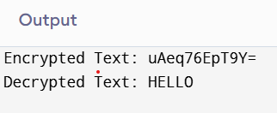

EX. NO: 7-IMPLEMENTATION OF RSA
AIM:
To write a C program to implement the RSA encryption algorithm.
ALGORITHM:
STEP-1: Select two co-prime numbers as p and q.
STEP-2: Compute n as the product of p and q.
STEP-3: Compute (p-1)*(q-1) and store it in z.
STEP-4: Select a random prime number e that is less than that of z.
STEP-5: Compute the private key, d as e * mod-1
(z).
STEP-6: The cipher text is computed as messagee
* mod n.

STEP-7: Decryption is done as cipherdmod n.
CODE:
#include <stdio.h>

long long power(long long base, long long exp, long long mod)
{
long long result = 1;
while(exp > 0)
{
result = (result * base) % mod;
exp--;
}
return result;
}

int main()
{
long long p, q, n, phi, e, d, m, c;

printf("Enter first prime number: ");
scanf("%lld", &p);

printf("Enter second prime number: ");
scanf("%lld", &q);

n = p * q;
phi = (p - 1) * (q - 1);

printf("Enter public key (e): ");
scanf("%lld", &e);

for(d = 1; (d * e) % phi != 1; d++);

printf("Enter message (number less than %lld): ", n);
scanf("%lld", &m);

c = power(m, e, n);
printf("\nEncrypted Message = %lld\n", c);

m = power(c, d, n);
printf("Decrypted Message = %lld\n", m);

return 0;
}

OUTPUT:
